- BESCOM ACKNOWLEDGEMENT
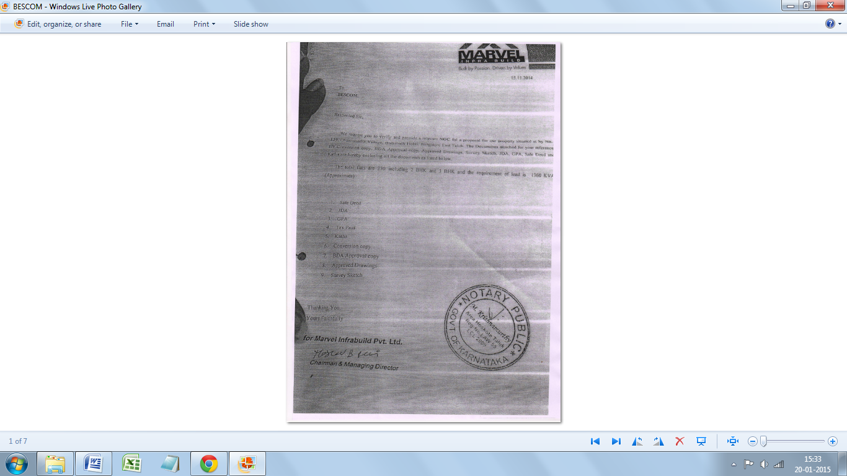

- BSNL ACKNOWLEDGEMENT
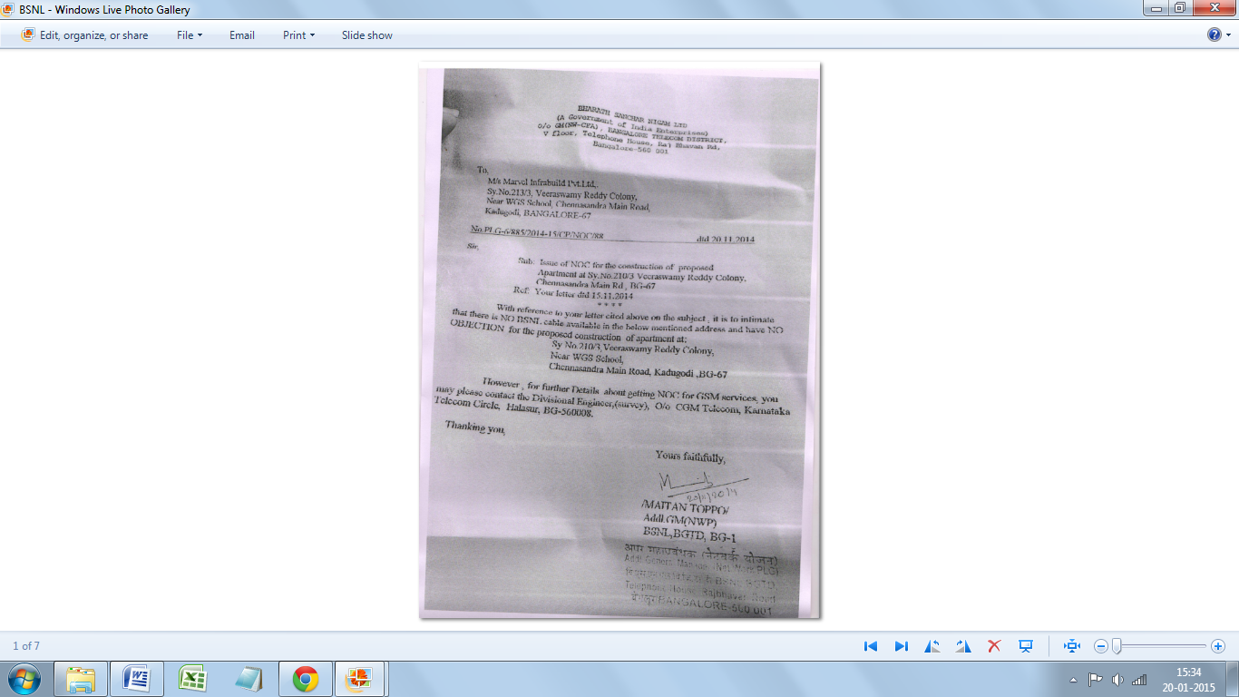

- BWSSB ACKNOWLEDGEMENT

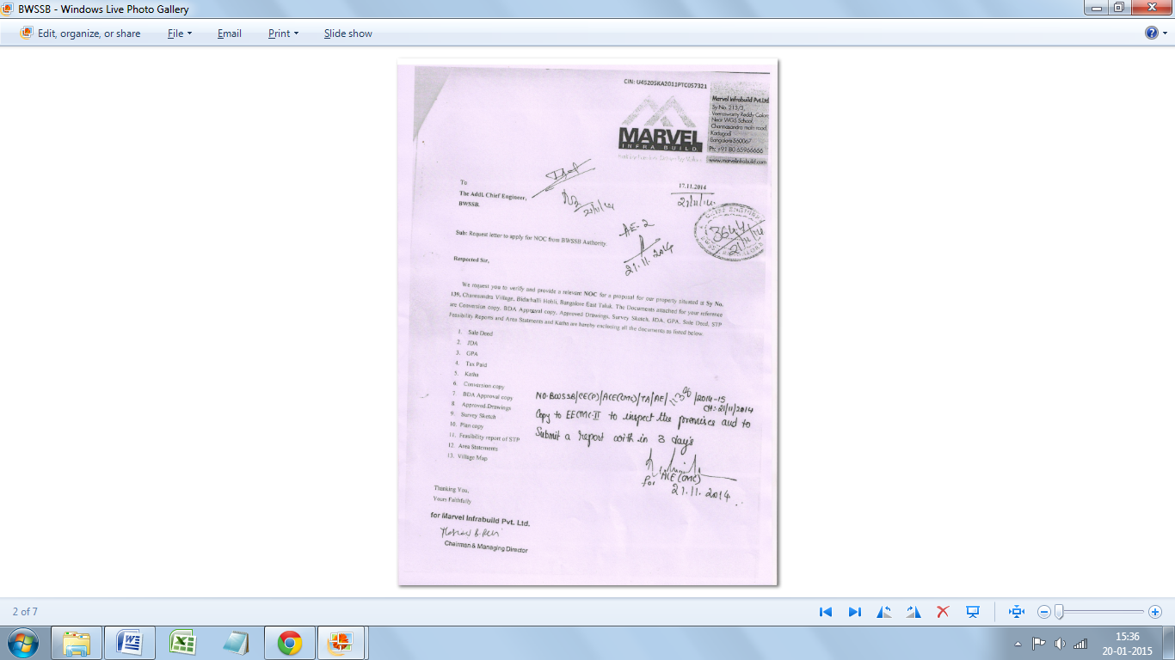

- FIRE ACKNOWLEDGEMENT
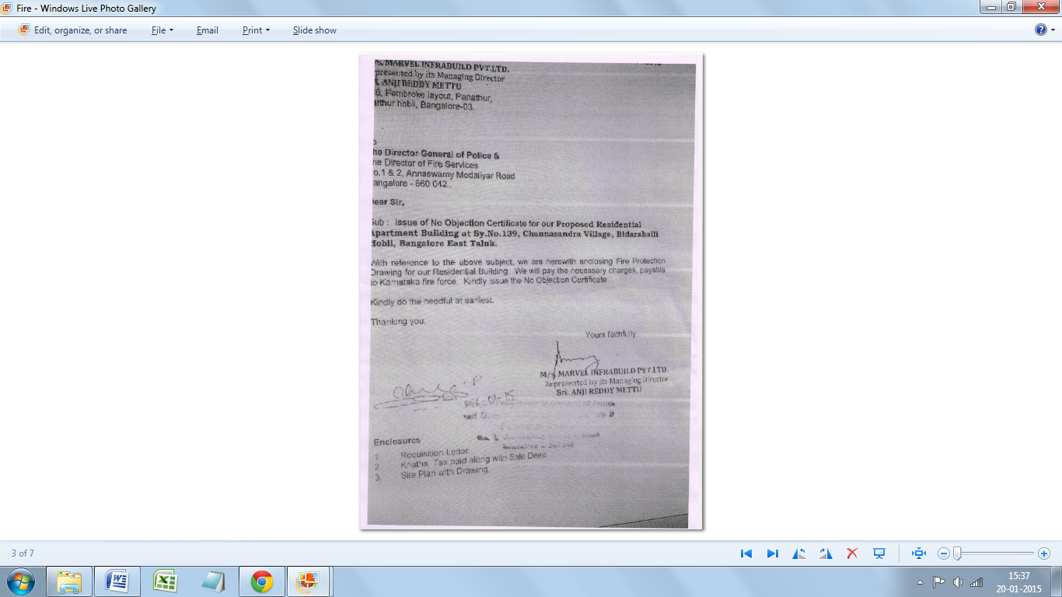

- POLLUTION CONTROL BOARD(PCB) ACKNOWLEDGEMENT
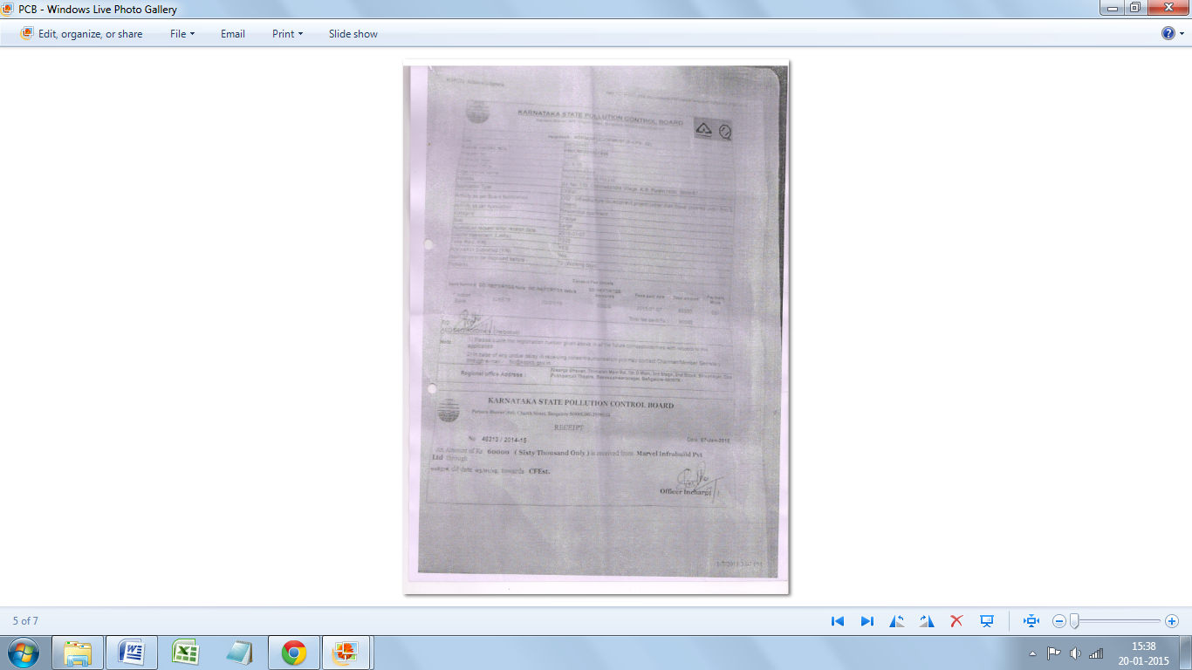

- SPECIAL NOTICE FROM BBMP
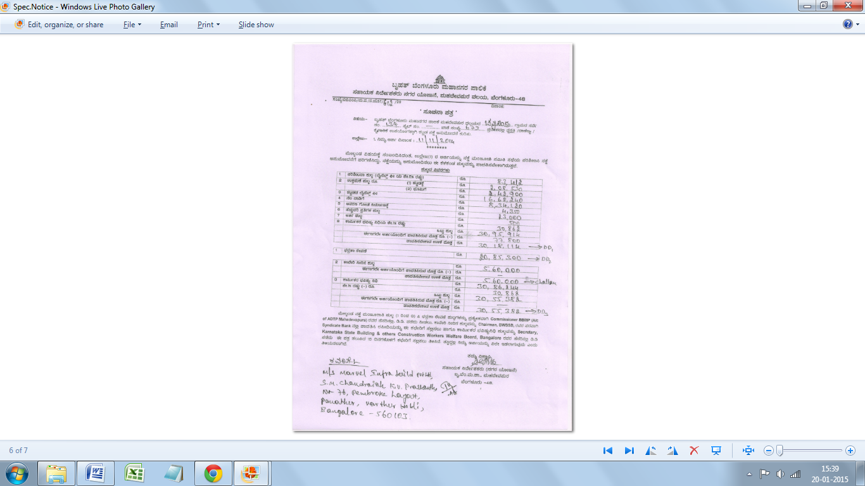

- HAL NOC
